**Cell & Microscope Assessment**  Name: ____________________ /52

**This page is to be completed when you are called to a microscope**

|  |  |  |
| --- | --- | --- |
| Task | Available mark | Your mark |
| Microscope tube/ Barrel lowered while looking from side | 1 |  |
| Microscope light and mirror set up correctly | 1 |  |
| Start on Low power | 1 |  |
| Use coarse focus before fine focus | 1 |  |
| Switch to higher objective lens while looking from side | 1 |  |
| Do not adjust barrel when changing lenses, use fine focus after switching to higher magnification | 1 |  |
| Diagram has appropriate title | 1 |  |
| Diagram is drawn in pencil | 1 |  |
| Diagram is neat (no shading, nice and clear lines) | 1 |  |
| Total magnification is written on diagram | 1 |  |
| Nucleus, cell membrane and cytoplasm is labelled on diagram | 3 |  |
| **Total mark** | **13** |  |

**Fill in the missing spaces.** 5

Always carry a microscope with one hand holding the arm and the other under the ____________.

To work out the total magnification, _______________ the magnification of the ocular lens by the magnification of the objective lens being used.

What would be the total magnification if the ocular magnification is 10x and the objective lens is 4x? ___________

What would be the total magnification if the ocular magnification is 10x and the objective lens is 10x? ___________

Which of the magnifications above would give you the largest field of view? _______________

**Write the part of the microscope next to the correct description.** 8

Used to move the microscope tube up and down. ________________________

Used to make fine adjustments on the focus. ________________________

The bottom of the microscope, used for support. ________________________

Connects the ocular lens to the objective lenses. ________________________

Combination of lenses at the viewing end of optical instruments. ________________________

Small platform where the specimen is mounted for examination. ________________________

Part of microscope that you look through. ________________________

Used to direct light up from underneath the stage. ________________________

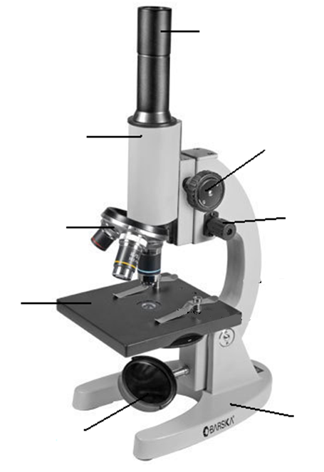**Label the microscope diagram.** 4

**Fill in the blanks on the following table:**  6

|  |  |
| --- | --- |
| **mm** | **um** |
| 0.5 |  |
|  | 600 |
|  | 48 |
| 0.25 |  |

What does mm stand for?

What does um stand for?

**Match the names below with their function:**  7

*Nucleus, Cytoplasm, Cell wall, Cell membrane, Mitochondria, Chloroplast, Vacuole.*

|  |  |
| --- | --- |
| **Organelle Name** | **Function** |
|  | To provide support for the cell |
|  | The control centre of the cell |
|  | Contains Chlorophyll which is needed for photosynthesis and makes plants green |
|  | Filled with fluid, used to store water and nutrients |
|  | Where cellular respiration happens to provide energy for the cell |
|  | The jelly like substance that fills the cell |
|  | Surrounds the cell to hold it together and control what enters and leaves |

**Look at the diagrams on the next page. One is a plant cell and one is an animal cell**

Which one is which? 3

* Top:_____________________
* Bottom:___________________

How could you tell?

Look at the names below. Use these names to label each diagram. Some of the names will be used on both diagrams, others will only be used on one diagram. Not all the organelles on each diagram will be labelled. 6

* Nucleus
* Cytoplasm
* Cell wall
* Cell membrane
* Mitochondria
* Chloroplast
* Vacuole

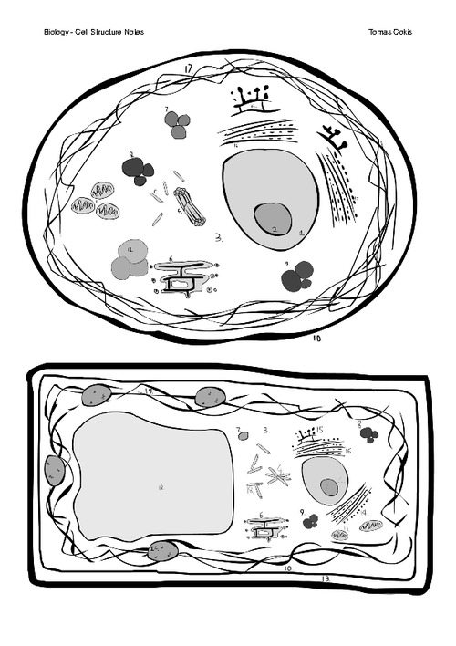

What term is used to describe the parts of a cell? _________________________ 1

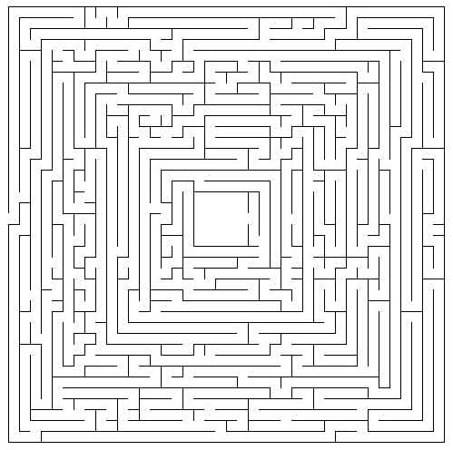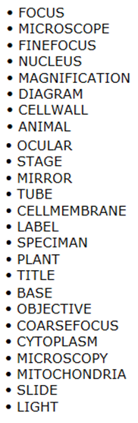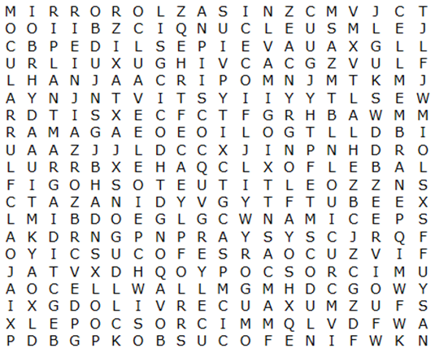

This page is not being assessed